Use the following table to answer the next 2 questions:

Brand of Car | Make of Car | Cost ($)
Toyota | RAV4 | 35,000
Ford | F-Series | 38,000
Tesla | Model 3 | 80,000
Honda | Civic | 27,600

- Which is the most expensive car on the list?
  - Toyota RAV4
  - Ford F-Series
  - Tesla Model 3
  - Honda Civic

- Which are the two cheapest cars on the list?
a) Toyota RAV4* b) Ford F-Series
c) Tesla Model 3 d) Honda Civic*
Reference:
Explanation:
Type: Multiple Choice Difficulty: Hard Category: Apply

- The diagram below shows a child’s swing.

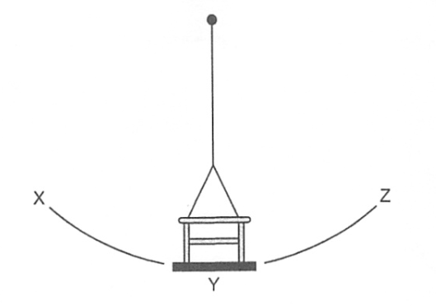
The swing is released from point X.
Which movement takes one period of oscillation?
- From X to Y
- From X to Z
- From X to Z and back to X
- From X to Z and back to Y
Answer: C

- Who was captain of the Titanic when it sank on April 15, 1912?
*Edward Smith
Christopher Columbus
Jack Sparrow
David Greene

- $\int{\frac{x+ \sin{x}}{1+ \cos{x}} dx}$ is equal to
  - $\log\left|1+ \cos{x}\right|+c$ *b. $\log\left|1+ \sin{x}\right|+c$ c. $x- \tan{x}+c$ d. $x \tan{\frac{x}{2}}$

Select the word whose underlined part differs from the other three in pronunciation in the next 2 questions.
- A. amazing *B. charge C. female D. taste
- *A. break B. breath C. thread D. tread
- A student sets up a circuit using a battery made of four cells, a resistor R, two identical lamps P and Q, and a switch. The circuit is shown in Fig. 6.1.
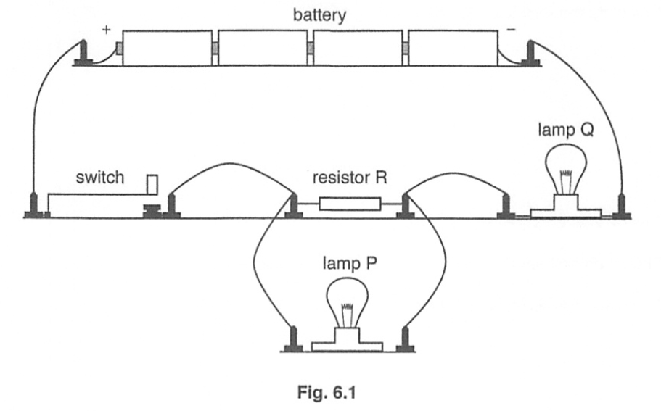

- Explain why in this circuit the current lamp Q is larger than the current in lamp P.
Answer: Lamp P is connected in parallel with resistor R hence it has lower current compare to Q.

- Explain why in this circuit lamp Q has different resistance from lamp P even though they are identical lamps.
Answer: As V=IR, given that P has less effective resistance due to being connect in parallel with R.
Suddenly she came upon a little three-legged table, all made of solid glass; there was (9) _________ on it except a tiny golden key, and Alice’s first (10) _________ was that it might belong to one of the doors of the hall; but, alas! either the locks were too large, or the key was too small, but at any rate it would not open any of them. (11) _________ , on the second time round, she came upon a low curtain she had not noticed before, and behind it was a little door about fifteen inches high: she tried the little golden key in the lock, and to her great delight it fitted!
Alice (12) _________ the door and found that it led into a small passage, not much larger than a rat-hole: she knelt down and looked along the passage into the loveliest garden you ever saw. How she longed to get out of that dark hall, (13) __________ wander about among those beds of bright flowers and those cool fountains, but she (14) _________ not even get her head through the doorway; “and even if my head would go through,” thought poor Alice, “it would be of very little use without my shoulders. Oh, how I wish I could shut up like a telescope! I think I could, if I only (15) _________ how to begin.” For, you see, so many out-of-the-way things had happened lately, that Alice had begun to think that very few things indeed were really impossible.
(16) __________ seemed to be no use in waiting by the little door, so she went back to the table, half hoping she might find another key on it, or at any rate a book of rules for shutting people up like telescopes: this time she found a little bottle on it, (“which certainly was not here before,” said Alice,) and round the neck of the bottle was a paper label, (17) __________ the words “DRINK ME,” beautifully printed on it in large letters.

15. The Grand Canyon is a steep-sided canyon carved by the Colorado River in [[*Arizona, Utah, California, Nevada]]. The canyon is a result of [[erosion, weathering]] which exposes one of the most complete geologic columns on the planet.

T F* 16. The United States has 52 states.
T F 17. Neil Armstrong was the first person to walk on the moon.
18. United States of America entered WWI in 1917. True or False?
____ 19. True or False*. Paris is the capital of Italy.

20. Match the following landmarks with the states they are in:
Statue of Liberty = New York
Grand Canyon = Nevada
Mount Rushmore = South Dakota
Golden Gate Bridge = California
Empire State Building = New York

Answer Scheme
- nothing
- thought
- thankfully, luckily
- opened
- and
- could
- knew
- there
- with

